CSC424 System Administration Lab Assignment 2

Due on 03/09/2017 11:59PM

Problems

Please answer the following questions (5) :

1. What is “inode” in Linux filesystem? How does Linux filesystem distinguish files?
   1. The inode is a data structure that is a tradition Linux style that contains information about individual files. The node stores the information in a file, directory or another file system.
2. What is an absolute path? What is a relative path? What are the differences between absolute path and relative path? Please give examples to justify your answer.
   1. An absolute path is the location of the filesystem object and is relative to the root directory. A relative path is a location of a file relative to the current directory. The difference between an absolute path and relative path is that an absolute path the location of a file or directory from the root directory and a relative path is the present working directory.
3. What is hard link? What is symbolic or soft link?
   1. A hard link is a file name that is stored within its parent directory, but not with the file itself. A symbolic link is a kind of file that points to another file.
4. What is root account? Why most systems allow root logins to be disabled?
   1. A root account is Unix’s omnipotent administrative user. The reason why most system allow root logins to be disable is because it disable the root access to any via console devices as well it prevents root access to OpenSSH suite of tools.
5. What are sudoers? What are the advantages of using sudo?
   1. A sudoers is a file that controls who can run what command and what user on what machine can do what with the control of particular command. An advantage of using sudo is that the accountability is much improved because of commands logging and users can do anything without having unlimited root privileges. The privileges can be revoked without the need to change the root password. As well as canonical list of all user with root privileges is maintained. And A single file can control access for an entire network.

Please complete following tasks. Please include both your commands used for each task and the screenshots indicates the completion of each task (5):

1. login using root account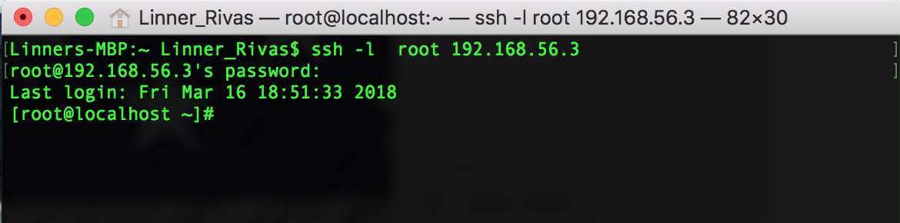
2. create a directory called “work"
   1. 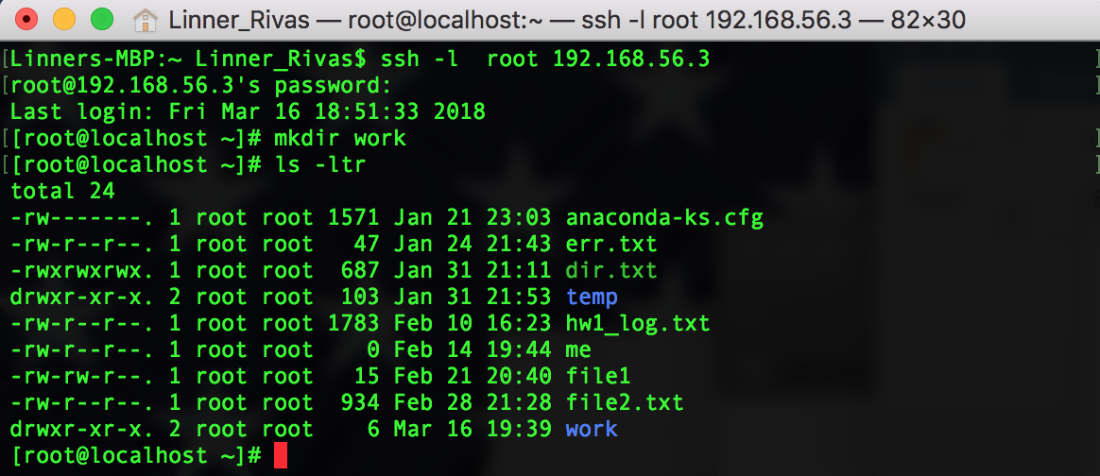
3. copy “/etc/passwd" to your “work" directory
   1. 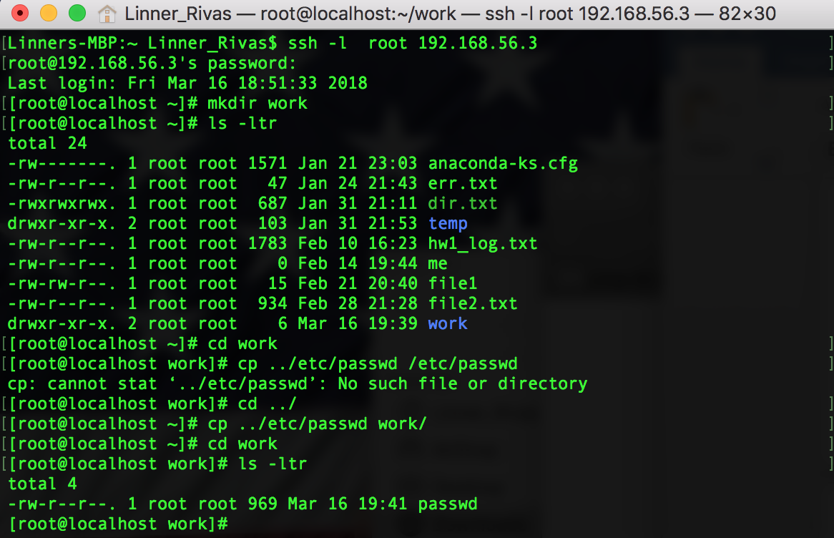
4. create a new group called “Admin"
   1. 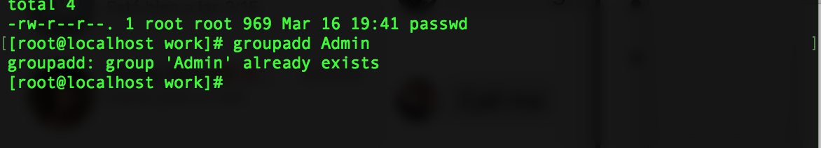
5. create a new user called “csc424" and assign the user to \Admin" group
   1. 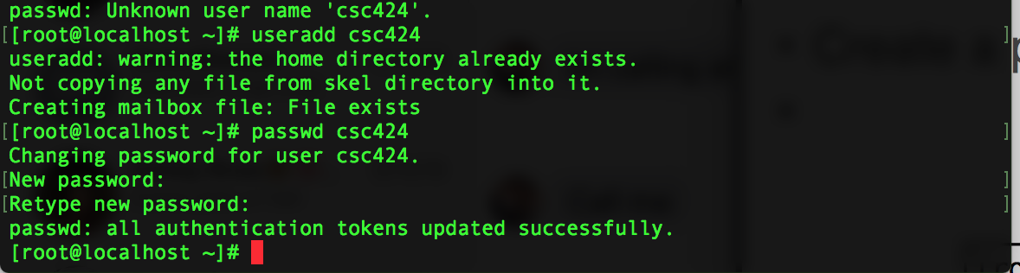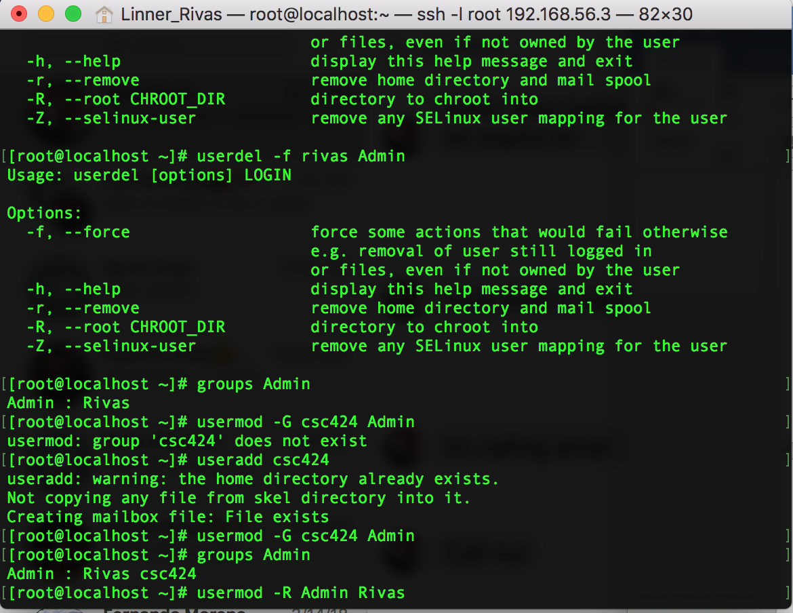
6. add users in “Admin" group into sudoers and give them root privilege
   1. 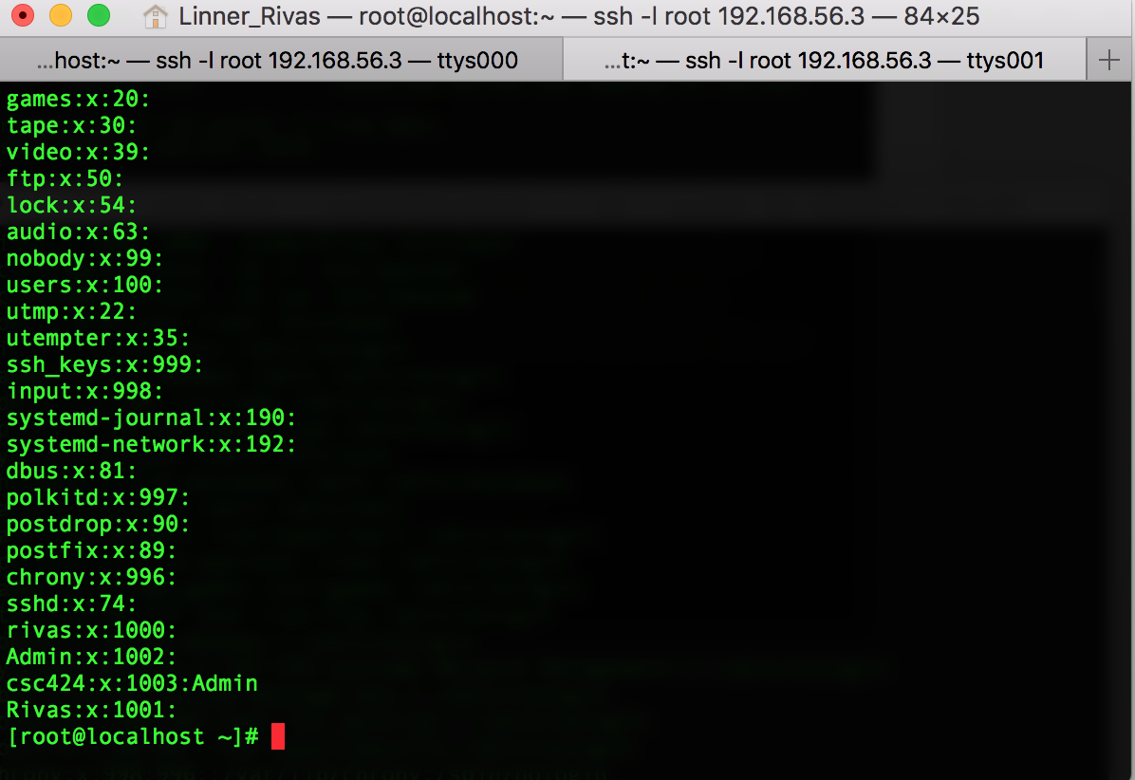
7. login to the system using “csc424"
   1. 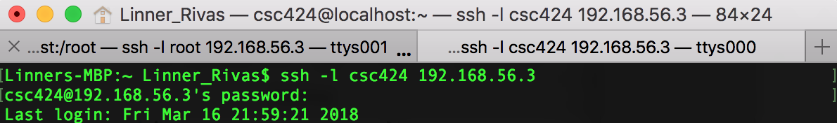
8. create a directory called “work" in user “csc424"'s home directory
   1. 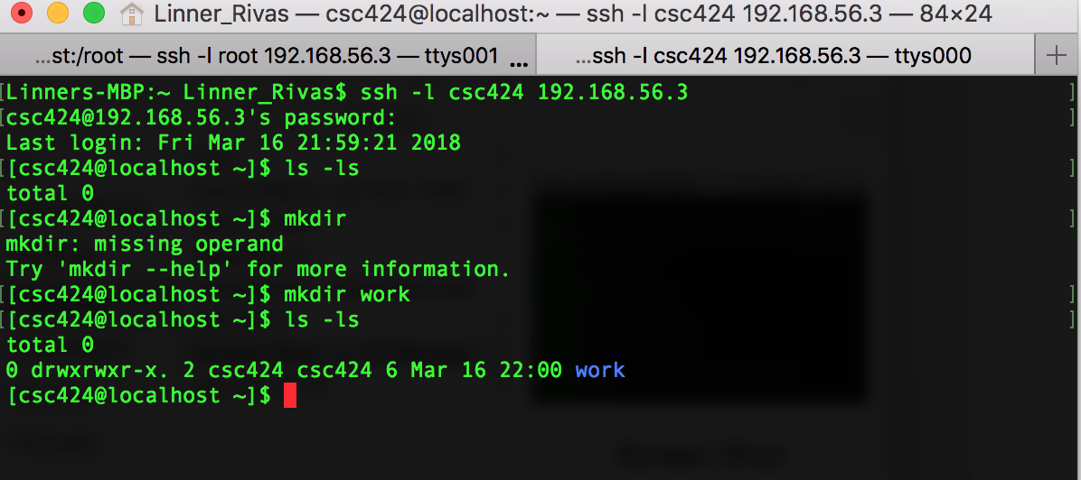
9. create a hard link called “passwd.hard" and a soft link called “passwd.soft" in user “csc424"'s work directory, both link to the passwd file in root's “work" directory
   1. 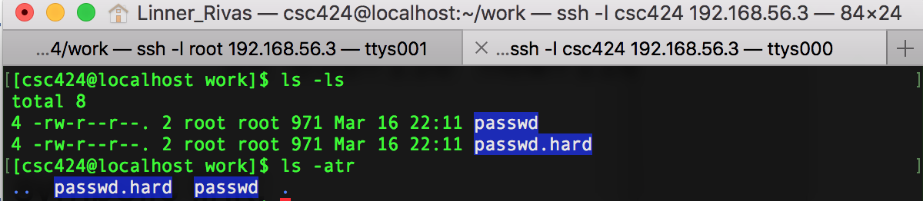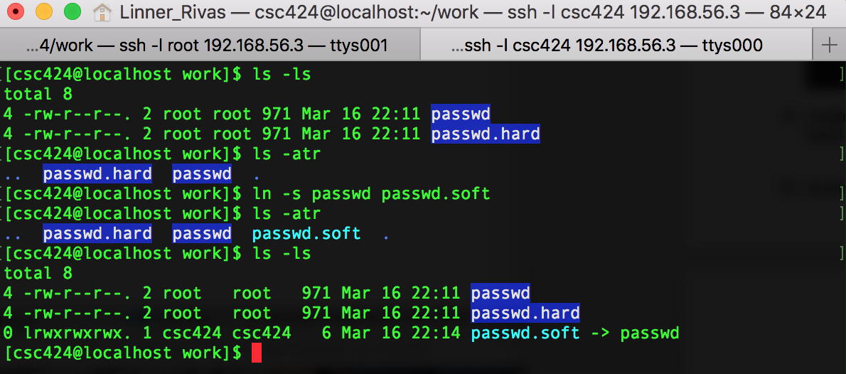
10. duplicate the line of “games" user's information at the end of the “passwd.soft" file.

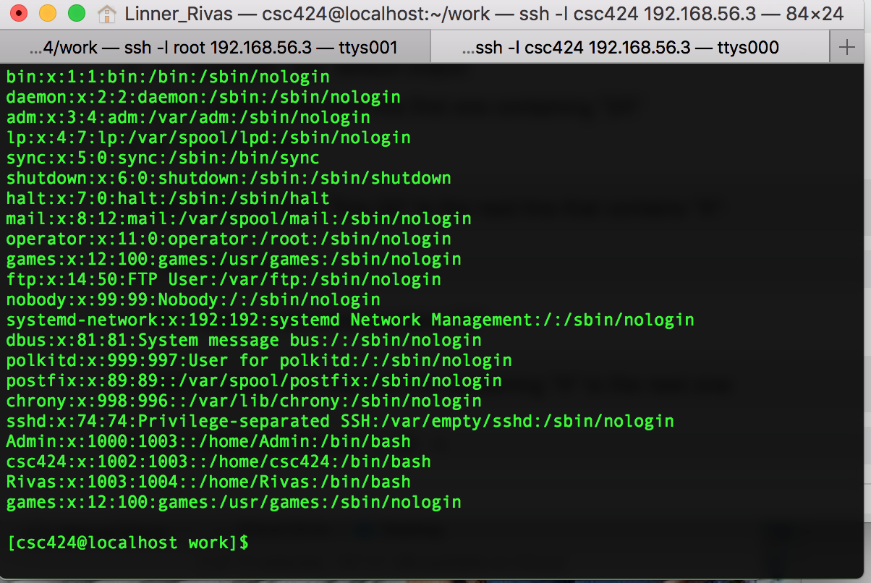

2